Jotform Payment Processor Integration

Purpose: This document describes the process of linking the payment processor, Square, and Jotform to allow online payment of permits and applications submitted.

# Connecting to Square:

Double click or click the click on edit form

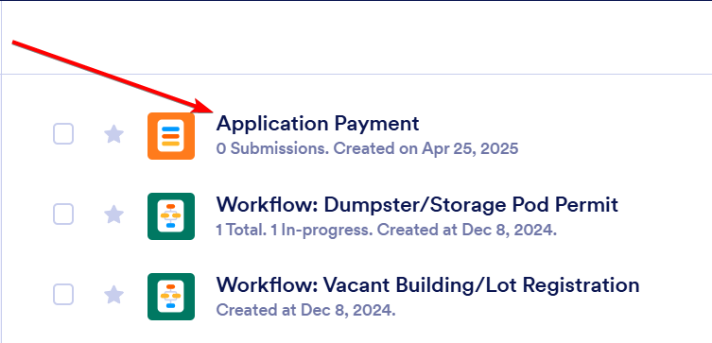

To connect Square click on the blue “Add a payment connection” link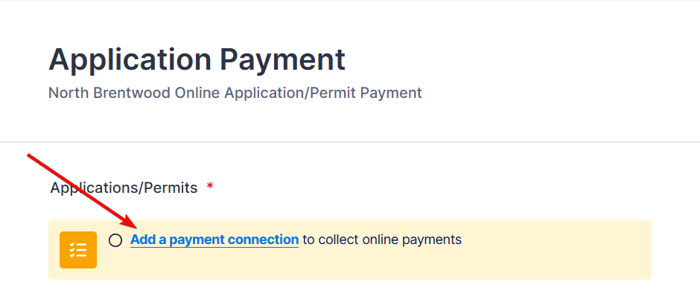

Name the connection anything desired but recommend naming it North Brentwood. This is where you can also turn on test mode to see the form in action without having to use real payment information. Then click on “Connect with Square”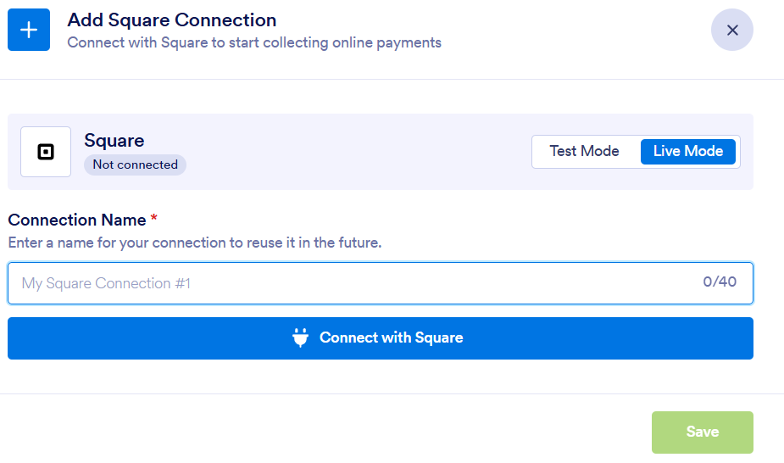

This new window will popup where you can log into the Square account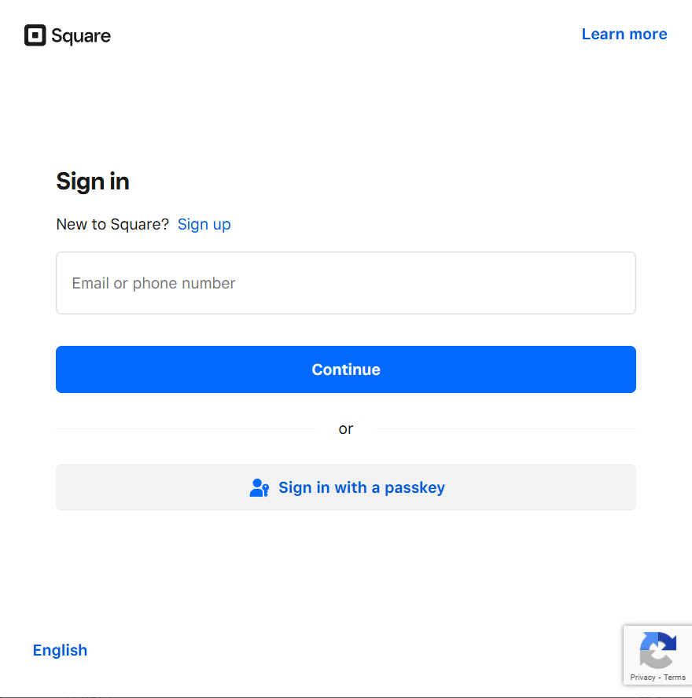

Everything should now be complete and the yellow “Add a payment connection” header should disappear.

# Integrating Payment:

Since there are 5 forms, there are also 5 workflows. We will be editing the workflows to add the payment option after an application/permit has been submitted.

Add a Payment Form on the left

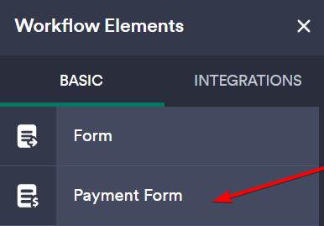

Click on Complete Settings

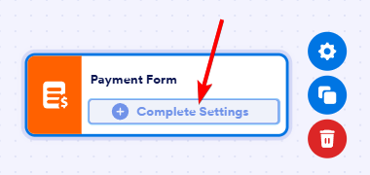

Click on Select a Form then on Application Payment, and save.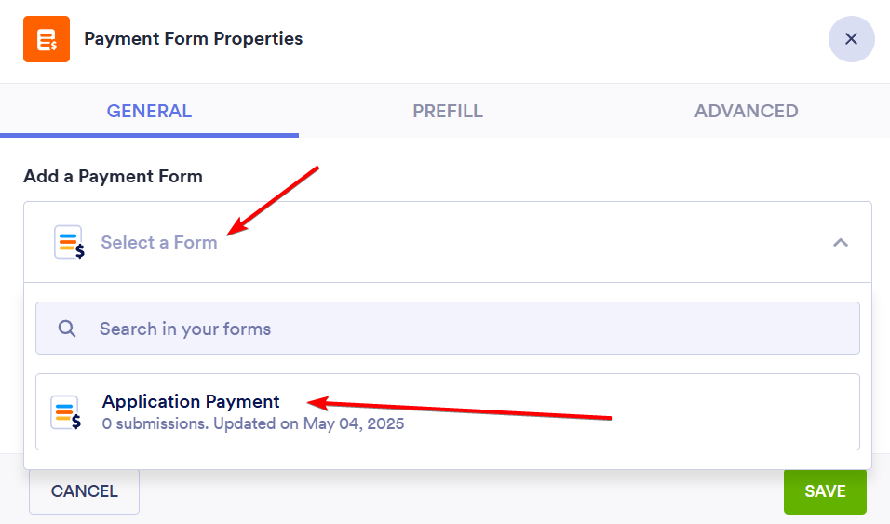

Edit the workflow so the Payment Form is after filling out the Application/Permit. You can do this by dragging the gray arrows in the workflow.